PROBLEM BASED ON SCENARIO

2

5

18

4

5

3

1

1

9

3

16

8

2

10

**PROBLEM SOLVED USING PRIM’S ALGORITHM:**

**STEP 1:**

E

A

F

1

B

CENTRAL OFFICE

G

D

C

H

**TABLE:**

|  |  |  |  |
| --- | --- | --- | --- |
| **V** | **Known** | **dv** | **Pv** |
| **A** | **1** | **0** | **0** |
| **B** | **0** | **1** | **A** |
| **C** | **0** | **∞** | **0** |
| **D** | **0** | **∞** | **0** |
| **E** | **0** | **∞** | **0** |
| **F** | **0** | **∞** | **0** |
| **G** | **0** | **∞** | **0** |
| **H** | **0** | **∞** | **0** |
| **CO** | **0** | **∞** | **0** |

**STEP 2:**

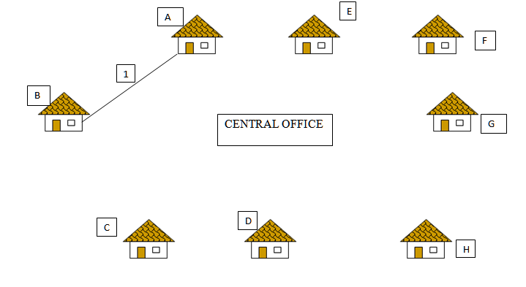

3

|  |  |  |  |
| --- | --- | --- | --- |
| **V** | **Known** | **dv** | **Pv** |
| **A** | **1** | **0** | **0** |
| **B** | **1** | **1** | **A** |
| **C** | **0** | **3** | **B** |
| **D** | **0** | **∞** | **0** |
| **E** | **0** | **∞** | **0** |
| **F** | **0** | **∞** | **0** |
| **G** | **0** | **∞** | **0** |
| **H** | **0** | **∞** | **0** |
| **CO** | **0** | **∞** | **0** |

**STEP 3:**

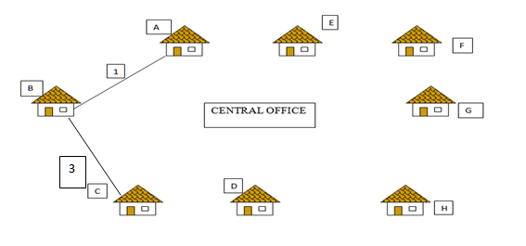

1

PROBLEM BASED ON SCENARIO

2

5

18

4

5

3

1

1

9

3

16

8

2

10

**STEP 1:**

E

A

F

1

B

CENTRAL OFFICE

G

D

C

H

**TABLE:**

|  |  |  |  |
| --- | --- | --- | --- |
| **V** | **Known** | **dv** | **Pv** |
| **A** | **1** | **0** | **0** |
| **B** | **0** | **1** | **A** |
| **C** | **0** | **∞** | **0** |
| **D** | **0** | **∞** | **0** |
| **E** | **0** | **∞** | **0** |
| **F** | **0** | **∞** | **0** |
| **G** | **0** | **∞** | **0** |
| **H** | **0** | **∞** | **0** |
| **CO** | **0** | **∞** | **0** |

**STEP 2:**



3

|  |  |  |  |
| --- | --- | --- | --- |
| **V** | **Known** | **dv** | **Pv** |
| **A** | **1** | **0** | **0** |
| **B** | **1** | **1** | **A** |
| **C** | **0** | **3** | **B** |
| **D** | **0** | **∞** | **0** |
| **E** | **0** | **∞** | **0** |
| **F** | **0** | **∞** | **0** |
| **G** | **0** | **∞** | **0** |
| **H** | **0** | **∞** | **0** |
| **CO** | **0** | **∞** | **0** |

**STEP 3:**



1

**Table:**

|  |  |  |  |
| --- | --- | --- | --- |
| **V** | **Known** | **dv** | **Pv** |
| **A** | **1** | **0** | **0** |
| **B** | **1** | **1** | **A** |
| **C** | **1** | **3** | **B** |
| **D** | **0** | **1** | **C** |
| **E** | **0** | **∞** | **0** |
| **F** | **0** | **∞** | **0** |
| **G** | **0** | **∞** | **0** |
| **H** | **0** | **∞** | **0** |
| **CO** | **0** | **∞** | **0** |

**STEP 4:**

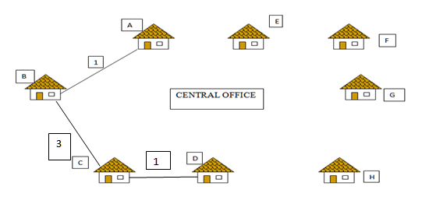

2

**Table:**

|  |  |  |  |
| --- | --- | --- | --- |
| **V** | **Known** | **dv** | **Pv** |
| **A** | **1** | **0** | **0** |
| **B** | **1** | **1** | **A** |
| **C** | **1** | **3** | **B** |
| **D** | **1** | **1** | **C** |
| **E** | **0** | **∞** | **0** |
| **F** | **0** | **∞** | **0** |
| **G** | **0** | **∞** | **0** |
| **H** | **0** | **2** | **D** |
| **CO** | **0** | **∞** | **0** |

**STEP 5:**

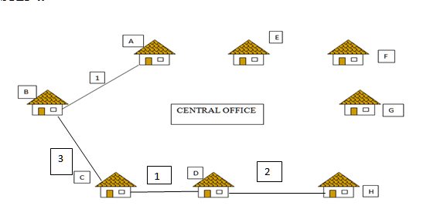

1

**Table:**

|  |  |  |  |
| --- | --- | --- | --- |
| **V** | **Known** | **dv** | **Pv** |
| **A** | **1** | **0** | **0** |
| **B** | **1** | **1** | **A** |
| **C** | **1** | **3** | **B** |
| **D** | **1** | **1** | **C** |
| **E** | **0** | **∞** | **0** |
| **F** | **0** | **5** | **G** |
| **G** | **1** | **1** | **H** |
| **H** | **1** | **2** | **D** |
| **CO** | **0** | **∞** | **0** |

**STEP 6:**

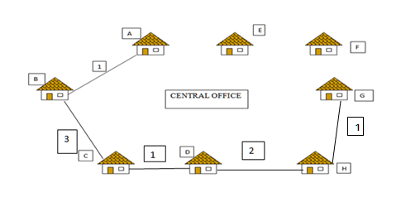

3

5

**Table:**

|  |  |  |  |
| --- | --- | --- | --- |
| **V** | **Known** | **dv** | **Pv** |
| **A** | **1** | **0** | **0** |
| **B** | **1** | **1** | **A** |
| **C** | **1** | **3** | **B** |
| **D** | **1** | **1** | **C** |
| **E** | **0** | **∞** | **0** |
| **F** | **1** | **5** | **G** |
| **G** | **1** | **1** | **H** |
| **H** | **1** | **2** | **D** |
| **CO** | **0** | **3** | **F** |

**STEP 7:**

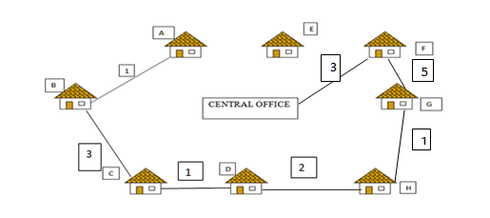

4

**MINIMUM COST:20**

**Table:**

|  |  |  |  |
| --- | --- | --- | --- |
| **V** | **Known** | **dv** | **Pv** |
| **A** | **1** | **0** | **0** |
| **B** | **1** | **1** | **A** |
| **C** | **1** | **3** | **B** |
| **D** | **1** | **1** | **C** |
| **E** | **0** | **4** | **CO** |
| **F** | **1** | **5** | **G** |
| **G** | **1** | **1** | **H** |
| **H** | **1** | **2** | **D** |
| **CO** | **1** | **3** | **F** |